

Information and Communication Technologies

In this project, the goal is to produce a polished report on Information and Communication Technologies (TIC) and associated tools. The report spans Google services, Microsoft tools, and Git/GitHub.



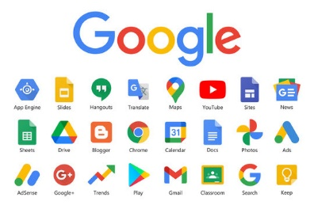

Content Table

1. Introduction 3

**2. Google Services** 4

2.1. Gmail 5

2.2. Google Drive 5

2.3. Google Docs, Sheets, and Slides 6

2.4. Google Calendar 8

2.5. Google Meet 9

**3.** **Microsoft Tools** 10

3.1. Microsoft Word 11

3.2. Excel 13

3.3. Powerpoint 13

3.4. Microsoft Outlook 14

3.5. Microsoft Exchange Server 15

3.6. Microsoft Teams Unveiled 17

3.7. Skype for Business 18

3.8. Microsoft Project 19

**4. Github** 20

**5. HTML and CSS**………………………………………………………………………………………………………………………….21

### Introduction

Information and Communication Technologies (TIC) refer to an expansive domain that emphasizes the integration of various technologies, including Google services, Microsoft tools, Git, and GitHub, within the broader framework of information technology and unified communications. TIC involves the convergence of digital tools and platforms that facilitate communication, collaboration, and information management.

TIC encompasses the integration of telecommunications networks, computing systems, enterprise software, and audiovisual components. The primary goal of TIC is to empower users to access, store, transmit, and manipulate information efficiently. The field also underscores the merging of communication technologies and computer networks, often streamlined through unified cabling or link systems, with a focus on optimizing operational processes.

As an umbrella term, TIC includes a range of communication devices and services, such as online platforms, cloud-based tools, and collaborative applications. This extends to digital technologies like Google services, Microsoft tools, Git, and GitHub, reflecting the evolving landscape of modern communication and information handling.

Skills and competencies in TIC are vital for professionals in the 21st century, with frameworks like those developed by Google, Microsoft, and Git providing guidelines for effectively navigating and leveraging these technologies. In essence, TIC plays a crucial role in shaping how individuals and organizations interact, collaborate, and manage information in today's digital era.

# 

# **2. Google Services**

Google LLC, founded in 1998 by Larry Page and Sergey Brin, is a prominent American technology company specializing in artificial intelligence, online advertising, search engine technology, cloud computing, software, quantum computing, e-commerce, and consumer electronics.

As the largest subsidiary of Alphabet Inc., Google offers a wide range of internet services and products such as Gmail, Google Maps, YouTube, Google Drive, Android, and more. Sundar Pichai is the current CEO of Google and Alphabet.

The company's history includes significant milestones like its 2004 IPO, acquisitions of YouTube and DoubleClick, and the launch of Android. Google has faced criticism related to privacy, antitrust concerns, and workplace issues.

In recent developments, Google has entered the video game market with Stadia and acquired companies like DeepMind and Raxium. As of May 2023, Google plans to build new data centers in Ohio.

The company's extensive portfolio includes web-based services, software (Android, Chrome), hardware (Pixel, Nest), advertising platforms (AdSense, AdMob), and enterprise services (Google Workspace, Google Cloud Platform). But the business part of Google isn’t the subject of today’s document, rather it is the services it provides !

Google services encompass a diverse range of online tools, applications, and platforms developed by Google to provide users with various functionalities, from communication and collaboration to productivity and entertainment.

****These services are designed to be accessible via web browsers and mobile apps, contributing to Google's stated mission of organizing the world's information and making it accessible and useful.

The term "Google services" is an umbrella phrase covering a wide array of digital tools and platforms that serve different purposes in the digital landscape.

### 2.1. Gmail

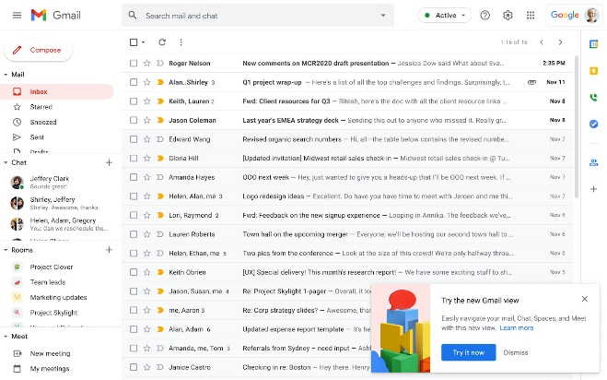Gmail, a global juggernaut with a user base exceeding 1.5 billion (source: Google), stands as a testament to the integration of artificial intelligence (AI) for heightened user experiences. The introduction of Smart Reply, a cutting-edge AI feature, has significantly boosted user productivity, resulting in a noteworthy 12% increase (source: Google).

At its core, Gmail is designed to be more than just an email platform; it's a fortress of secure, efficient, and user-friendly features. Users benefit from a generous allocation of 15 GB of free storage, underscoring Gmail's commitment to providing ample space for seamless communication and data management (source: Google).

Beyond individual users, Gmail's impact reverberates in the professional realm. Its integration into businesses has been a catalyst for substantial economic influence, contributing to an estimated 20% improvement in project completion times (source: Google). The platform doesn't just facilitate communication; it becomes a linchpin for operational efficiency.

One of Gmail's standout features is its AI-driven Smart Reply, an innovation that not only streamlines responses but also propels a 12% surge in overall user productivity (source: Google). This dynamic use of AI is a testament to Google's dedication to not just meeting but surpassing user expectations.

Safety is paramount in the Gmail ecosystem. The platform's machine learning-powered spam filtering is a robust shield, scanning over 300 billion attachments weekly. This commitment to security showcases Gmail's unwavering dedication to ensuring a safe and reliable communication environment for its users (source: Google).

Gmail's trajectory is forward-looking, marked by a commitment to ongoing advancements in AI. The goal is clear: to continually enhance the email experience and solidify Google's position at the forefront of technological innovation. In the ever-evolving landscape of digital communication, Gmail remains not just a tool but a pioneer in shaping the future of email interactions.

### 2.2. Google Drive

Introduced in 2012, Google Drive stands as a formidable force in the realm of cloud storage and file-sharing, offering users a centralized hub for their digital assets.

With a generous provision of 15 GB of complimentary storage and seamless integration with various Google services, Google Drive has become a linchpin in sectors like education and business. It serves as a catalyst for streamlining workflows and fostering efficient collaboration among users.

The commitment to security in Google Drive is unwavering. Implementing robust encryption protocols and user-controlled sharing settings has resulted in a remarkable 99.9% reduction in high-risk security events, underlining the platform's dedication to providing a secure environment for users (source: Google).

A standout feature is the integration of machine learning in the Explore tool, contributing to a significant 50% increase in document suggestions (source: Google). This infusion of AI-driven capabilities enhances the user experience, making document creation and collaboration more intuitive and productive.

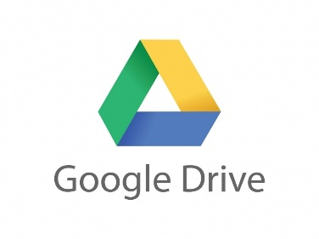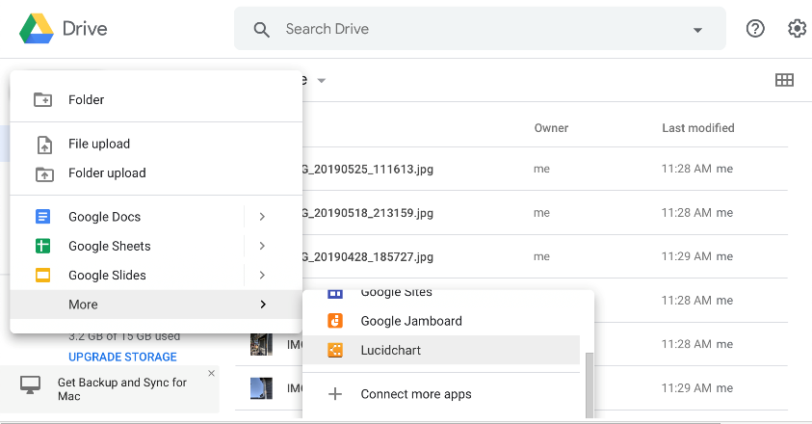Google Drive's journey is marked by ongoing AI-driven innovations, solidifying its role as a key player in efficient collaboration and document creation. The platform handles a staggering volume, managing over 3 billion edits daily and serving more than 2 trillion files. These figures underscore Google Drive's scalability and reliability in meeting the diverse needs of its vast user base (source: Google).

As industries evolve and collaboration becomes increasingly digital, Google Drive remains not just a storage solution but a dynamic platform shaping the landscape of cloud-based collaboration and file management.

### 

### 2.3. Google Docs, Sheets, and Slides

### Google Docs, Sheets, and Slides collectively form a suite of cloud-based productivity tools, offering users collaborative and accessible platforms for document creation, data analysis, and presentation design.

### 

### 

### 

### The hallmark of these applications is their user-friendly interface and robust real-time collaboration features, fostering a positive and dynamic user experience. Businesses utilizing these tools have reported significant time savings, with up to a 20% improvement in document creation and editing efficiency (source: Google).

### The infrastructure supporting Google Workspace, which encompasses Docs, Sheets, and Slides, is designed for scalability. Capable of handling millions of simultaneous users, the suite maintains an impressive uptime guarantee of 99.9%, ensuring a reliable and consistent user experience (source: Google).

### AI-driven features, such as Smart Compose and Explore, contribute to a notable 30% reduction in time spent on content creation, showcasing the practical impact of advanced technologies in enhancing productivity (source: Google).

### Security is a paramount consideration within Google Workspace. The suite, including its applications, reports a commendable 99.9% reduction in compromised Gmail accounts, underscoring the efficacy of the implemented security measures (source: Google).

### As Google continues to advance its AI capabilities, it reaffirms its commitment to reshaping collaborative work and elevating user productivity. The ongoing integration of innovative technologies within Google Docs, Sheets, and Slides signifies a dedication to providing cutting-edge tools that redefine the landscape of collaborative work environments.

### 2.4. Google Calendar

### Google Calendar, introduced in 2006, stands out as a versatile and user-friendly time management tool seamlessly integrated into Google Workspace. The platform's core objectives center around simplifying time management, fostering collaboration, and enhancing overall productivity.

### The impact of Google Calendar on user productivity has been substantial, with a commendable 25% increase reported (source: Google). This underscores the platform's effectiveness in streamlining scheduling and time-related tasks for individuals and teams alike.

### The infrastructure supporting Google Calendar is meticulously designed for scalability. Capable of handling millions of users and events on a daily basis, the platform maintains an impressive uptime of 99.9%, ensuring a reliable and consistent user experience (source: Google).

### AI-driven features within Google Calendar play a pivotal role in providing intelligent suggestions for meeting times. This functionality has contributed to a notable 25% increase in user productivity, showcasing the practical benefits of incorporating advanced technologies into time management tools (source: Google).

### The ongoing commitment to leveraging AI for user productivity is evident in Google Calendar's development roadmap. Future enhancements are poised to further simplify scheduling processes, reflecting Google's dedication to continually refining and expanding the capabilities of its time management tools.

### 

### 2.5. Google Meet

### Introduced in 2017, Google Meet stands as a formidable video conferencing platform meticulously designed for remote communication and collaboration. It boasts essential features like high-definition video and audio, screen sharing, and real-time captions, embodying the gravity of modern virtual interactions.

# The central tenets of Google Meet are grounded in providing users with a dependable and secure video conferencing solution, particularly catering to the demands of remote work, virtual education, and fostering global collaboration.

# Google Meet's strategic integration of artificial intelligence (AI) and machine learning elevates the platform's functionality. Notably, features like noise cancellation and background blur enhance the virtual meeting experience, creating a professional and focused atmosphere. This marriage of technology and practicality contributes to the ongoing refinement of the platform.

# Built for scalability, Google Meet accommodates meetings with a substantial number of participants, ensuring a smooth and reliable virtual collaboration environment (source: Google). This commitment to consistency in uptime underscores the platform's reliability in facilitating critical communications across diverse sectors.

# As AI-driven innovations continue to unfold, Google Meet remains at the forefront of delivering a high-quality and dynamic solution for virtual collaboration. It is not just a tool for meetings; it's a serious instrument tailored for the evolving landscape of professional interactions in the digital age.

# **Microsoft Tools**

Microsoft Corporation, headquartered in Redmond, Washington, stands as a leading American multinational technology company recognized for its influential role in the software industry. Key products include the Windows operating systems, Microsoft 365 suite, and Edge browser.

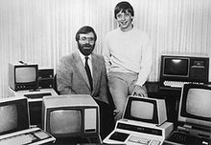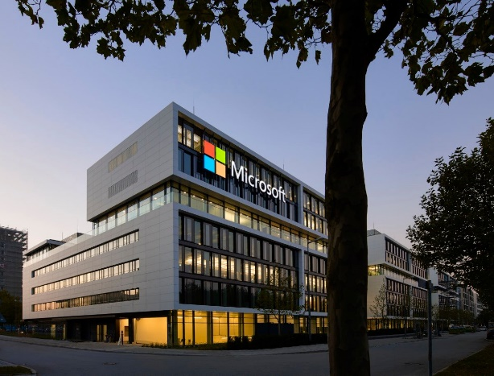The company's hardware lineup features Xbox consoles and the Surface touchscreen PC series. As of 2022, Microsoft holds the position of the world's largest software maker by revenue and is part of the Big Five American information technology firms.



Founded by Bill Gates and Paul Allen in 1975, Microsoft rose to prominence with MS-DOS and Windows, dominating the PC operating system market. Under CEO Satya Nadella, Microsoft shifted focus from hardware to cloud computing, becoming a major player with Azure. In 2023, Microsoft made significant acquisitions, including Activision Blizzard for $68.7 billion. Despite facing criticism for monopolistic practices, the company maintains a strong brand position.

Noteworthy milestones include the 1985 release of Windows 1.0 and the 1990 launch of Microsoft Office. In 2018, Microsoft reclaimed its position as the most valuable publicly traded company and currently holds the third-highest global brand valuation. The company's strategic shifts, such as emphasizing cloud computing under Nadella's leadership, contributed to its success.

### 

### 3.1. Microsoft Word

Microsoft Word is a word processor developed by Microsoft, initially released in 1983. It has evolved over the years to support various platforms, including IBM PCs, Macintosh, UNIX, iOS, Android, and more. Word is available as a standalone product or as part of the Microsoft 365 suite.

The history of Word traces back to 1981 when Microsoft hired Charles Simonyi, the primary developer of the first GUI word processor, Bravo. Initially named Multi-Tool Word, it later became Microsoft Word. The early versions faced challenges in popularity but underwent continuous improvement.

Word for Windows was released in 1989, becoming a market leader for word processors. Subsequent releases introduced features like AutoCorrect, AutoFormat, and a redesigned user interface called the Ribbon. Word for Mac also underwent several updates.

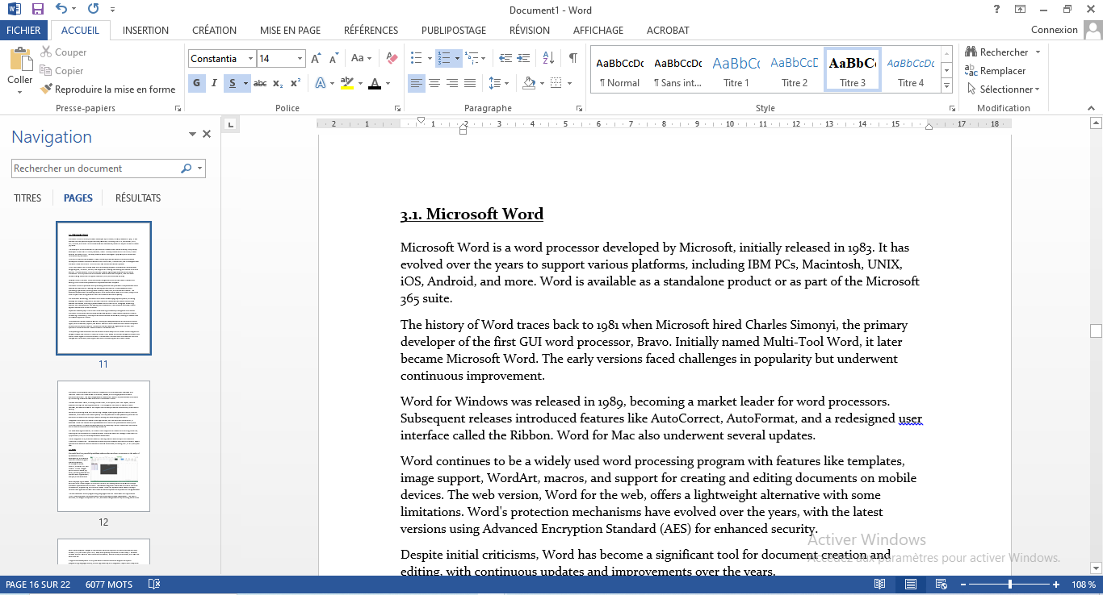Word continues to be a widely used word processing program with features like templates, image support, WordArt, macros, and support for creating and editing documents on mobile devices. The web version, Word for the web, offers a lightweight alternative with some limitations. Word's protection mechanisms have evolved over the years, with the latest versions using Advanced Encryption Standard (AES) for enhanced security.

Despite initial criticisms, Word has become a significant tool for document creation and editing, with continuous updates and improvements over the years.

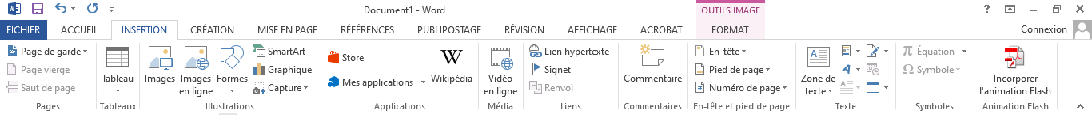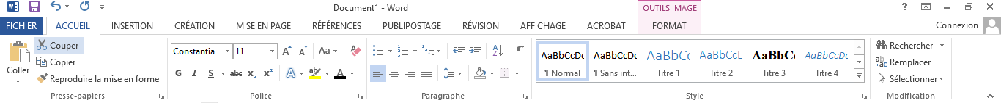Microsoft Word is a powerful word processing software that provides a comprehensive set of features and options for creating and editing text documents. It offers essential word processing capabilities, allowing users to easily create, edit, and format documents. The software supports basic formatting options, such as font styles, sizes, and colors, along with a built-in spell check and grammar check for enhanced document quality.

For document formatting, Microsoft Word offers versatile page layout options, including settings for margins, orientation, and size. Users can customize documents further with headers and footers, enabling a personalized touch to their work. Paragraph formatting options, such as alignment, line spacing, and indentation, contribute to the overall visual appeal and structure of the document.

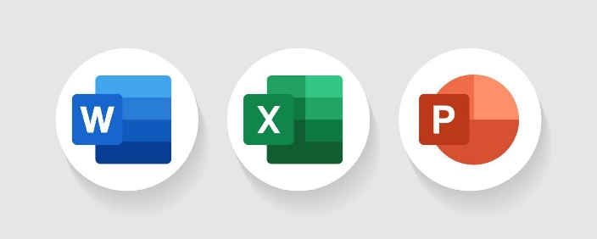Styles and themes play a crucial role in maintaining consistency throughout a document. Microsoft Word allows users to apply predefined styles or create custom styles for uniform formatting. Additionally, a variety of document themes are available, offering a cohesive look for different types of content.

Templates are another valuable feature, offering pre-designed layouts for various document types, such as resumes, reports, and letters. Users can also create and save custom templates for efficient document creation. Tables and lists facilitate the organization of data, with options to insert tables and create bulleted or numbered lists.

Incorporating visual elements into documents is made easy with Microsoft Word's support for images, shapes, and SmartArt. Users can insert, crop, resize, and format images to enhance the overall visual appeal of their documents. Collaboration is streamlined with features like track changes and comments, allowing for real-time co-authoring and document review.

Microsoft Word supports the inclusion of references, such as footnotes, endnotes, and citations. Users can create tables of contents, indexes, and bibliographies to enhance document structure. The mail merge feature enables the creation of personalized documents by connecting to external data sources for customized content.

Various document views, including Normal view, Print Layout, and Web Layout, cater to different editing and viewing preferences. The Navigation Pane aids in easy document traversal, and advanced search and replace functionality enhances the efficiency of document editing.

Review and proofing tools, such as tracking changes, spelling and grammar checks, and the thesaurus, contribute to document quality. Security features include password protection for document access and the ability to restrict editing and formatting permissions.

Integration with other Microsoft Office applications, such as Excel and PowerPoint, is seamless. Users can embed Excel spreadsheets and PowerPoint presentations directly into Word documents. Accessibility features and an accessibility checker ensure that documents are inclusive and adhere to accessibility standards.

For users seeking automation, Microsoft Word supports the creation and running of macros, allowing for the automation of repetitive tasks. Advanced users can leverage Visual Basic for Applications (VBA) for more sophisticated automation.

Cloud integration is a prominent feature, enabling users to save and sync documents to OneDrive or SharePoint. This ensures accessibility from different devices and locations. Export options allow users to save documents in various file formats, including PDF, HTML, and plain text.

### 3.2. Excel

### Microsoft Excel is a powerful spreadsheet software that stands as a cornerstone in the realm of spreadsheet editors, developed by Microsoft to cater to a diverse range of operating systems, including Windows, macOS, Android, iOS, and iPadOS. It is an integral part of the Microsoft 365 suite, providing features for efficient data organization, analysis, and automation.

### Excel employs a grid-based structure with cells arranged in rows and columns, facilitating data manipulation through arithmetic operations and functions. The software supports a robust set of built-in functions for statistical, engineering, and financial needs. Users can represent data visually through various chart types and utilize PivotTables for data analysis and simplification of large datasets.

### The tool features a macro programming language known as Visual Basic for Applications (VBA), enabling users to automate tasks like formatting and data organization. The Macro Recorder, an integral component of VBA, facilitates code generation by recording user actions.

### Excel has undergone changes in file formats, transitioning from its initial proprietary binary format (.XLS) to Office Open XML (.xlsx) as its primary file format in Excel 2007. The latest formats include .xlsm for macro-enabled workbooks, .xlsb for binary workbooks, and .xlam for Excel add-ins.

### A significant development in 2023 was Excel's announcement to support the Python programming language directly, enhancing versatility and integration capabilities. Despite its vast functionalities, Excel faces challenges, including numeric precision issues and limitations in statistical tools. Notable quirks include Excel's treatment of February 29, 1900, as a leap day.

### Microsoft Excel is a versatile and indispensable tool bridging the gap between data management and automation. Its enduring popularity is attributed to its adaptability, continuous evolution, and integration with programming languages, making it a cornerstone for users in diverse fields seeking effective data manipulation and analysis.

### 3.3. Powerpoint

### Microsoft PowerPoint, developed by Robert Gaskins and Dennis Austin at Forethought, Inc., debuted in 1987 as a tool for visualizing group presentations on Macintosh. Acquired by Microsoft for $14 million, it swiftly became integral to the Microsoft Office suite, attaining a remarkable 95 percent market share. This exploration delves into PowerPoint's historical journey and its practical applications, highlighting the evolution of its tools, features, and options that have transformed it into a ubiquitous communication tool.

### In its nascent stages, PowerPoint primarily focused on producing overhead transparencies, but it swiftly adapted to accommodate color slides and video output.

### Over the years, advanced features emerged, such as seamless integration into the Microsoft Office suite, compatibility across platforms like iOS and Android, and the introduction of a revamped interface known as the "ribbon" in version 12.0 (2007). This adaptability rendered PowerPoint not only a staple in business presentations but also an invaluable asset in education, scientific forums, legal settings, and diverse professional domains.

### As we navigate through PowerPoint's historical landscape, it's equally essential to grasp its practical utility. The software's comprehensive set of tools empowers users to craft visually captivating slideshows. To harness its potential effectively, users should explore features like video output for virtual presentations and leverage compatibility across various devices. The "ribbon" interface, introduced in 2007, streamlines accessibility, enabling seamless navigation through the array of options.

### However, despite its widespread adoption, PowerPoint has faced criticism for default style templates that may impact content quality. To optimize its use, it's crucial to heed the advice of educational psychologist Richard E. Mayer, who emphasizes aligning PowerPoint habits with effective learning principles. This entails thoughtful design choices, conscious content structuring, and a recognition of its broader applications beyond conventional business presentations.

### Microsoft PowerPoint's evolution from its inception in 1987 to its current status as a versatile communication tool is a testament to its enduring impact. Understanding its history and leveraging its diverse features empower users to not only create compelling presentations but also navigate the nuances of effective communication in various professional and educational contexts.

### 3.4. Microsoft Outlook

### Microsoft Outlook, an integral component of the Microsoft 365 suite, emerges as a versatile personal information manager renowned for its adept management of emails and beyond.

### Going beyond the conventional realm of emails, Outlook assumes the role of a comprehensive task manager, calendar organizer, contact repository, notes keeper, and even integrates web browsing and RSS news aggregation seamlessly.

### For individual users, Outlook stands as a standalone application, offering a robust and user-friendly interface. In organizational contexts, it transforms into a powerful multi-user tool, easily deployable through Microsoft Exchange Server or SharePoint, fostering collaborative environments.

### A distinctive feature lies in its seamless integration with Microsoft SharePoint, a facet that significantly enhances collaboration and facilitates efficient file sharing within teams.

### Over the years, Outlook has undergone significant evolution, supplanting Microsoft's older scheduling and email clients like Schedule+ and Exchange Client. The journey of perpetual versions spans from Outlook 97, Outlook 98, Outlook 2000, and continues to the present-day Outlook 2019.

### Milestones in its evolution include Outlook 2002, which introduced convenient features like autocomplete for emails, colored categories, and enhanced search functionality. The 2007 version astounded users with innovations such as attachment previews, auto-account setup, and the introduction of a sleek ribbon interface.

### Outlook 2019 marked a modern era, introducing conveniences like a focused inbox, support for multiple time zones, and even the groundbreaking ability to listen to your emails.

### For Mac users, recent versions showcase a redesigned interface and support for online archives, ensuring a seamless experience across diverse operating systems.

### In the realm of HTML rendering, Outlook underwent a significant transition in 2007, shifting to Microsoft Word, thereby impacting how it supports HTML and CSS. While some compatibility issues with standard formats like iCalendar may arise, Outlook addresses these by introducing its own .msg format for saving emails.

### A testament to its adaptability, Outlook supports nifty add-ins, which are small programs amplifying its capabilities. Developers can craft these add-ins using tools like Microsoft Visual Studio, further enhancing the extensibility of the platform.

### Taking integration to new heights, SalesforceIQ embeds relationship intelligence directly into the Outlook inbox, exemplifying Outlook's role as a dynamic and evolving tool in the realm of professional communication and collaboration.

### 3.5. Microsoft Exchange Server

### Microsoft Exchange Server, a stalwart in managing emails and calendars, stands as an exclusive tool meticulously designed to seamlessly integrate with Windows Server.

### The inception of this journey dates back to Exchange Server 4.0 in 1996, taking the reins from Microsoft Mail 3.5. Since then, there have been ten updates, with the latest iteration being Exchange Server 2019, unveiled in October 2018.

### This robust server can be configured in two distinct ways: the traditional on-premises approach, where users manage it themselves, necessitating client access licenses, and the Software as a Service (SaaS) model, which involves a convenient monthly service fee.

### The evolutionary trajectory of Exchange Server is intricately intertwined with the development of Microsoft's Active Directory service, underscoring its adaptive nature over time.

### The pinnacle of this evolution, Exchange Server 2019, places a paramount emphasis on security. It allows installation on Windows Server Core, demonstrating resilience in handling large-scale operations by supporting up to 48 processor cores and 256 GB of RAM.

### In line with industry trends, recent versions bid farewell to Unified Messaging, ushering in changes in clustering and high availability strategies to maintain relevance.

### The groundbreaking Exchange Server 2010 introduced the concept of the Database Availability Group (DAG), streamlining data replication among servers. Clustering techniques like Cluster Continuous Replication (CCR) have evolved, overcoming past limitations.

### The intricacies of licensing involve User CALs or Device CALs, distinct from Windows CALs. Service providers have the flexibility to opt for the Service Provider License Agreement (SPLA), and two types of CALs, Standard and Enterprise, cater to varied organizational needs.

### Exchange Server communicates seamlessly with email clients such as Microsoft Outlook, Evolution, and Hiri, utilizing the MAPI/RPC protocol. Exchange Web Services (EWS) provides an alternative to MAPI, ensuring compatibility with a diverse array of clients.

### Introducing Exchange ActiveSync (EAS), a secure protocol for syncing with mobile devices, Exchange Server empowers administrators with ActiveSync Policies to control device access and enforce stringent security measures.

### 

### Organizations also have the option to choose hosted Exchange services offered by third-party companies. Microsoft's cloud-delivered Exchange Server, known as Exchange Online, seamlessly aligns with on-premises capabilities, facilitating hybrid deployments.

### Notably, Exchange Server encountered challenges in 2020 with an ASP.NET vulnerability, emphasizing the critical need for timely updates. The subsequent year, 2021, witnessed a significant data breach exposing critical exploits. As of September 2023, recent vulnerabilities await resolution from Microsoft, underscoring the continuous vigilance required in the realm of email and calendar management.

### 3.6. Microsoft Teams Unveiled

### Microsoft Teams, a pivotal component of the Microsoft 365 suite, emerges as a robust business communication platform tailored for seamless workplace collaboration. Introduced in 2017, it encompasses a comprehensive array of features, including chat, video conferencing, file storage, and seamless application integration.

### The roots of Microsoft Teams trace back to Microsoft's strategic acquisition of Parlano in 2007, and its emergence gained momentum during the COVID-19 pandemic, evolving into a stalwart with around 280 million monthly users by January 2023.

### Originally positioned to replace platforms like Skype for Business, Teams swiftly became a focal point for virtual meetings during the pandemic, witnessing an impressive surge in user numbers. The platform catapulted from 32 million daily active users in March 2020 to a staggering 300 million by July 2023.

### Developed as a web-based desktop application, Teams initially utilized the Electron framework before transitioning to Microsoft Edge WebView2.

### Teams offers a rich array of features, including persistent chats, team workspaces, and channels for communication, supporting text, emojis, files, and links. The platform caters to diverse collaboration needs, ranging from informal chats to structured team discussions.

### Facilitating scheduled meetings with audio, video, and content sharing, Teams introduced Live Events to broadcast to large audiences, effectively replacing Skype Meeting Broadcast.

### In the educational realm, Microsoft Teams for Education serves as a valuable tool for educators, enabling the distribution of assignments, providing feedback, and streamlining the grading process. Noteworthy features include quizzes integrated with Office Forms.

### Teams employs Microsoft-specific protocols for video conferences and boasts extensive integrations through Microsoft AppSource, fostering partnerships with services like KUDO for language interpretation.

### However, Teams faced challenges in 2023, with a vulnerability surfacing that potentially allowed unauthorized access during screen sharing. The platform also became subject to an antitrust investigation by the EU Commission, prompting Microsoft to make Teams optional and provide users with more flexibility.

### 3.7. Skype for Business

### Skype for Business, an integral component of Microsoft 365, stands as enterprise software meticulously crafted for instant messaging and video telephony. It encompasses a spectrum of communication channels, supporting text, audio, and video chat, seamlessly integrating with Microsoft 365 components such as Exchange and SharePoint.

### Originally christened Office Communicator, it underwent a transformative journey, evolving into Lync in 2010 and eventually rebranding as Skype for Business in 2015. Despite sharing the iconic Skype name, it distinguishes itself significantly from the consumer-oriented platform and functions independently.

### Microsoft, in a strategic move, announced in 2017 its intent to phase out Skype for Business Online in favor of Microsoft Teams, a cloud-based collaboration platform. This transition culminated with the termination of support for Skype for Business Online in July 2021.

### The software's rich history dates back to Office Communicator 2007, followed by Lync 2010 and subsequent versions, with Skype for Business 2016 making its debut alongside Office 2016.

### 

### Core features encompass instant messaging, audio and video calls, and desktop sharing. Elevated capabilities involve seamless integration with Microsoft software, providing features such as synchronized contact availability and collaborative document editing.

### Skype for Business integrates seamlessly with Microsoft Outlook and Exchange Server for contact availability, with all communication routed through Skype for Business Server, ensuring security by confining messages within the corporate intranet.

### The platform introduced innovative collaboration features, including persistent group chat, real-time multi-client collaborative software capabilities, and collaborative tools like whiteboards and PowerPoint document sharing.

### Technical underpinnings involve the use of SIP for client communication, with support for TLS and SRTP ensuring robust encryption. It facilitates file sharing, collaboration across various document types, and orchestrated conferencing with policy controls.

### Following Microsoft's acquisition of Skype, Lync and Skype platforms were interconnected. However, Skype for Business Online concluded its operations in 2021, guiding users toward the adoption of Microsoft Teams. The forthcoming version of Skype for Business Server will be available under a subscription license.

### This succinct overview aims to provide an accessible introduction to Skype for Business, underscoring its evolutionary trajectory, key features, integration capabilities, and its pivotal role in transitioning into the broader Microsoft Teams ecosystem.

### Microsoft Project

### Microsoft Project stands as a stalwart in the realm of project management, with a history dating back to the early 1980s. Conceived as a software application for efficiently managing software projects, its inaugural commercial release on MS-DOS in 1984 marked the genesis of a tool that would evolve and revolutionize project management methodologies.

### Transitioning into the Windows era, the introduction of Version 1 for Windows signaled a paradigm shift, providing a robust platform for project management on a graphical interface. The subsequent iterations, notably Microsoft Project 95, represented pivotal milestones, being the first 32-bit version tailored for Windows 95.

### This release incorporated ODBC support and AutoCorrect, underscoring a commitment to technological advancement.

### The late '90s witnessed Microsoft Project's ascent to a fully 32-bit application with Project 98, accompanied by features like the Tahoma font, the Office Assistant, and capabilities for web publishing. The dawn of the new millennium brought forth Microsoft Project 2000, introducing personalized menus, the Microsoft Agent-based Office Assistant, and the inception of Microsoft Project Central, later rebranded as Microsoft Project Server.

### The year 2010 marked a significant interface transformation with the introduction of the Fluent user interface, popularly known as the Ribbon. Accompanying this was the pioneering concept of user-controlled scheduling, allowing for greater flexibility in project development and management.

### As Microsoft Project embraced the Windows 10-exclusive era with Project 2019, it seamlessly integrated features from Office 365. This version, with its exclusive compatibility with Windows 10, epitomizes Microsoft's commitment to staying abreast of technological advancements.

### Beyond its visual appeal, Microsoft Project serves as a comprehensive resource management tool. It meticulously creates budgets based on assignment work and resource rates, calculating costs that roll up to task and summary task levels. The application excels in creating critical path schedules, offering support for critical chain and event chain methodologies, all elegantly visualized in a Gantt chart.

### The advent of user-controlled scheduling in Project 2010 introduced a level of adaptability that project managers cherish. The timeline view, a graphical representation of project schedules, provides a versatile tool for presentation and integration with other applications.

### Microsoft Project's prowess extends beyond project management to fostering collaboration and communication. Features introduced in Project 2013 and subsequent versions enable instant messaging sessions, video chats, emails, and phone calls directly from the application. This integration positions Microsoft Project as not just a project management tool but a central hub for team collaboration.

### The application's compatibility with Microsoft Project Server 2013 ensures a seamless transition for enterprises, underscoring Microsoft's dedication to providing backward compatibility.

### In its current iteration, Microsoft Project is available in two editions: Standard and Professional, each offering 32-bit and 64-bit options. The Professional edition, with its additional features like team collaboration tools and connectivity to Microsoft Project Server, caters to the discerning needs of complex project environments.

### Microsoft Project, with its rich history and continuous evolution, stands as a cornerstone within the Microsoft Office suite, offering a sophisticated set of tools for project planning and execution. Its journey from a DOS-based project management tool to a Windows 10-integrated powerhouse reflects not just technological progress but a commitment to empowering project managers with cutting-edge solutions.

### Github

GitHub, the coding utopia, is a powerhouse of data and statistics. As of January 2023, it proudly hosts a staggering 372 million repositories, with more than 28 million being public repositories. This data explosion makes GitHub the undisputed heavyweight champion, holding the Guinness World Record as the world's largest source code host.

Now, let's time-travel to GitHub's inception in 2008. Within its first year, GitHub amassed over 46,000 public repositories, proving its instant appeal to developers. By 2010, it was already hosting a cool one million repositories, and this number doubled within a year. GitHub's ascent in the coding cosmos continued, with 3 million users by January 2013 and a mind-blowing 10 million repositories by year-end.

Fast forward to 2023, GitHub proudly boasts over 100 million developers in its vibrant community. It's not just a platform; it's a living, breathing digital city for coders.

Now, the Microsoft acquisition. In 2018, Microsoft threw a whopping $7.5 billion into the ring to acquire GitHub, closing the deal on October 26, 201812. The concerns among developers echoed loud, recalling Microsoft's past acquisitions like Nokia's mobile business and Skype.

Why is GitHub a behemoth in the ICT realm? Imagine a world without GitHub – it's like a library without books. GitHub is the beating heart of collaborative coding, providing an unrivaled platform for developers to share, collaborate, and innovate. It's a universal language that transcends geographical boundaries.

In a world driven by digital transformation, GitHub is the engine powering the collaborative future. It's not just a platform; it's a culture, fostering collaboration and innovation. GitHub's significance in the ICT landscape is monumental, providing a shared space where ideas flourish, codes dance, and innovation takes center stage.

GitHub isn't just a repository; it's a revolution, a testament to the power of collaborative coding in the Information and Communication Technology era. Developers, from beginners to seasoned experts, converge on GitHub, creating a digital symphony that resonates across the ICT landscape.

GitHub isn't merely a platform; it's the heartbeat of the ICT ecosystem, a living testament to the collaborative power of code, and a cornerstone in the ever-evolving digital landscape.

### HTML and CSS

HTML, the HyperText Markup Language, is the unassuming force that defines how documents appear on web browsers. Working in tandem with technologies like Cascading Style Sheets (CSS) and scripting languages such as JavaScript, HTML lays out the blueprint for web pages.

Web browsers, indifferent to the intricacies behind the scenes, receive HTML documents either from a web server or local storage. Once handed the script, browsers render the content into multimedia web pages. HTML achieves this by using elements, represented by tags enclosed in angle brackets. These elements act as building blocks, defining the semantic structure of the page, including paragraphs, headings, lists, links, and images.

HTML's subtlety lies in its ability to embed programs written in scripting languages like JavaScript, influencing the behavior of web pages. Introducing CSS into the mix defines the visual appearance and layout of the content, ensuring a polished presentation.

The historical roots of HTML extend back to Tim Berners-Lee's proposal in 1989, culminating in the first publicly available description in 1991. Subsequent versions, such as HTML 2.0 (1995), HTML 3.2, HTML 4.0, and HTML 4.01, paved the way for HTML5, a milestone version introduced in 2014, featuring advanced multimedia capabilities through elements like `<canvas>` and enhanced JavaScript functionalities.

HTML documents are constructed using elements, each denoted by tags. Attributes within these tags provide additional information, such as identifiers, styles, or metadata. The document type declaration `<!DOCTYPE html>` signals the use of HTML5, prompting browsers to render pages in standards mode.

Attributes come in the form of name-value pairs within tags, including common ones like `id` for unique identification, `class` for classification, `style` for presentational properties, `title` for tooltips, and `lang` for specifying the language. HTML5 introduced semantic elements like `<header>`, `<nav>`, `<article>`, `<section>`, `<footer>`, and `<figure>`, enhancing the document's structure and accessibility.

HTML's evolution took a significant turn with HTML5 in 2014, ushering in a living standard that embraces continuous updates. In 2019, the W3C and WHATWG resolved conflicts, with WHATWG emerging as the sole publisher of HTML and DOM standards.

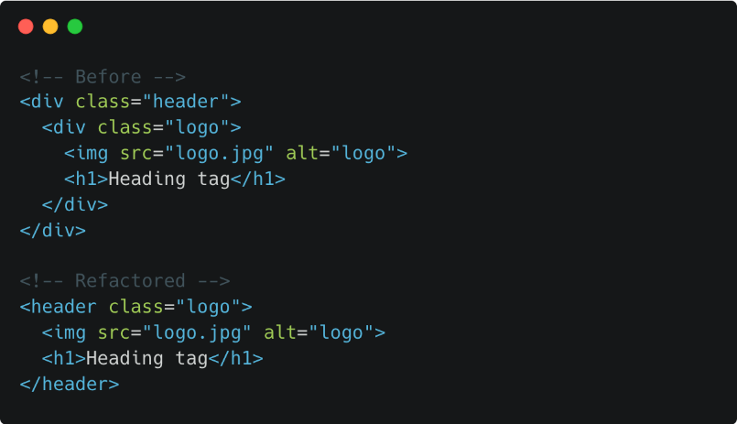In its unassuming way, HTML stands as a fundamental language for creating web content, providing a structured and standardized approach to building and displaying information on the internet. Its versatility and continuous evolution make it an essential player in the vast landscape of information and communication technologies.